5 ReactJS-HOL-HANDS-ON-ANSWERS
We create the CSS Module in a file called “CohortDetails.module.css” and update it with the following components as stated in the hands-on guide in below code:
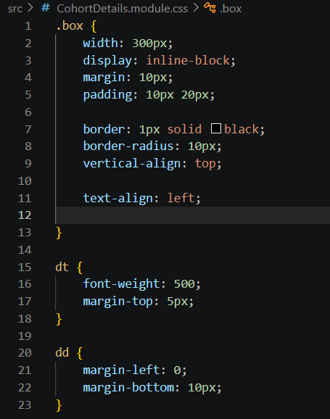

Then we import the CSS Module in the “CohortDetails.js” file

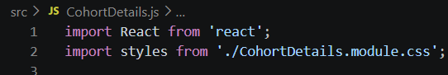

Then we apply- the box class to the container div; define the styles for <h3> element to use “green” colour font when the cohort statis is “ongoing” and “blue” colour in all other scenarios.
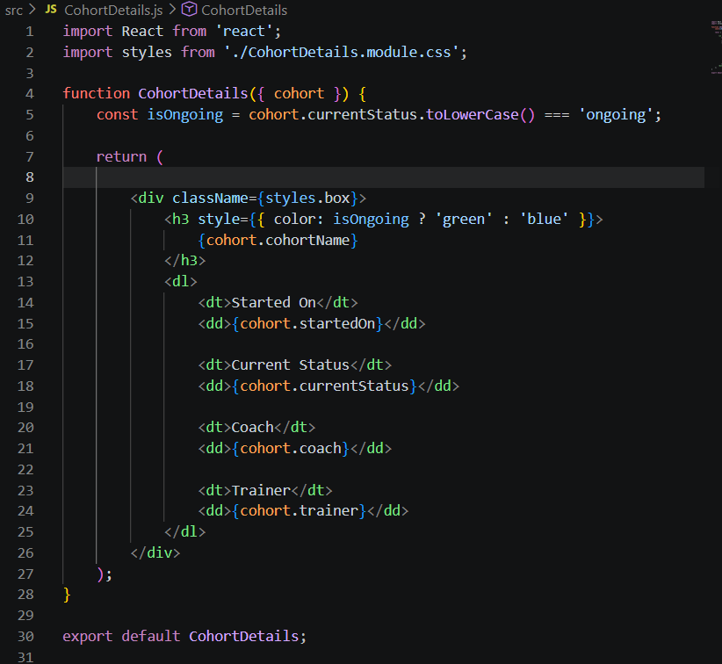
And the final result is shown here –
